Überholung der Sitzschienen

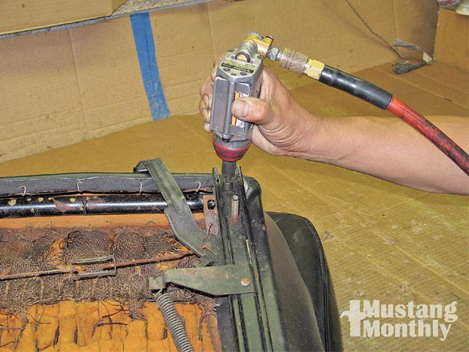
Removal of the tracks begins by unbolting the screws with a large Phillips-head bit, either a large screwdriver or an air tool, as used here. Be very careful when releasing the track; spring pressure can cause it to snap back suddenly

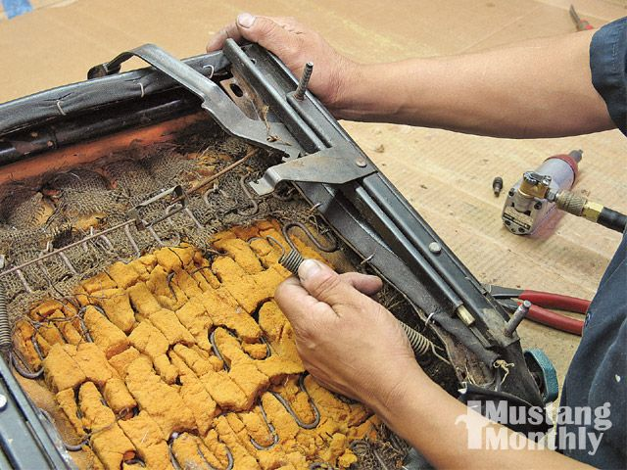
Next, remove the springs. They aren't real stiff and can be removed by hand. Carefully stretch them out and remove one end from its hole, then take the spring off.

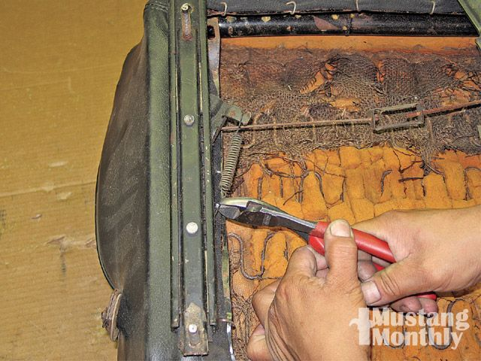
The main spring for the adjustment lever in the previous photo and this one on the other side both need to be removed.

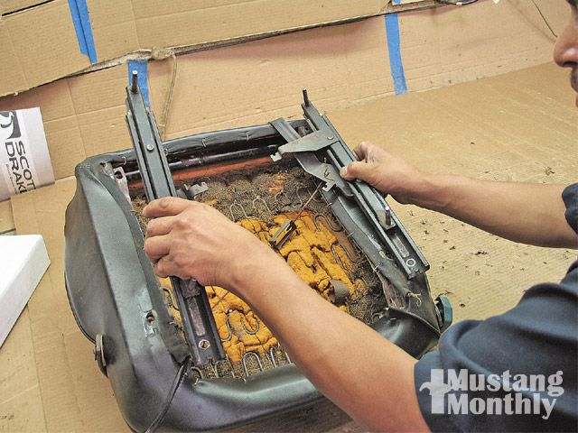
With the screws and springs out, both tracks can be removed from the seat as shown

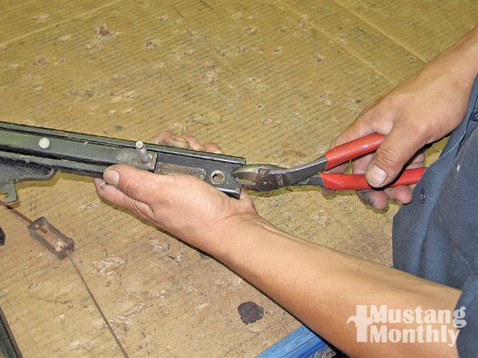
There are small metal tabs on the end of the tracks. These need to be pried down so the seat mounting bars, which slide back and forth, can be separated from the tracks. A pair of pliers and careful pressure on the tabs will do the trick

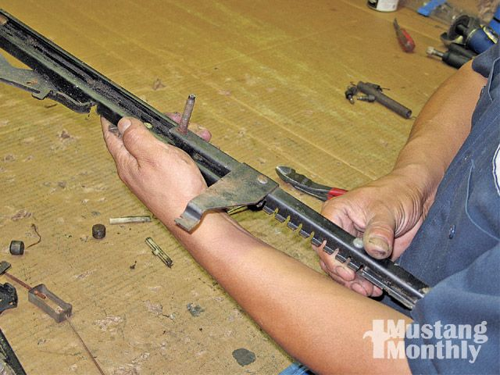
With the tabs bent out of the way, the mounting bar easily separates from the track. If not, this is where you'll be able to determine why a track is difficult to operate and take appropriate steps to repair it. Maybe something is bent or stuck inside the tracks, or perhaps something needs to be replaced. If so, Mustang Country has used seat tracks in stock

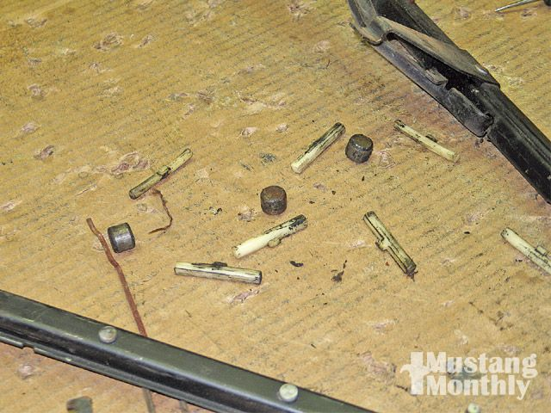
These nylon tabs help locate the seat bars in the tracks and will fall out when the seat mounting bars are separated from the tracks. Also shown here are the round metal circular metal pieces that serve as bearings in the tracks. They also come out on disassembly and are easily reinstalled when everything is put back together.

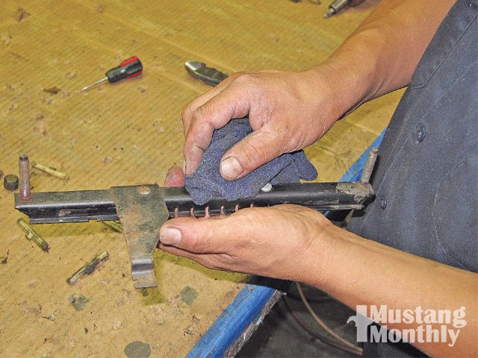
Once everything is apart, clean the parts with a rag and some sort of solvent, such as lacquer thinner or spray lubricant, which can be sprayed onto the parts so they can be cleaned with a rag. A small amount of gasoline will also work. You want to get the parts clean as they will be repainted after they dry.

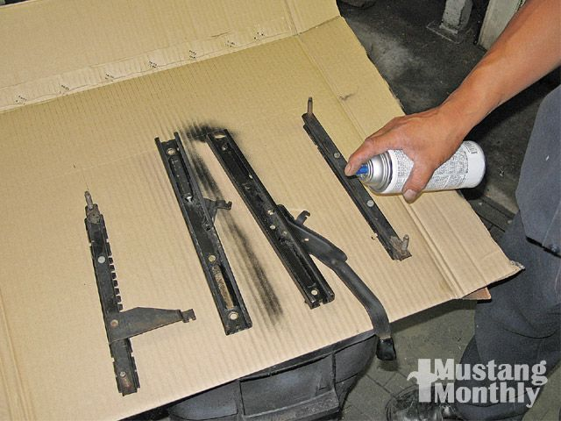
Once everything is clean and dry, a few coats of flat- or semi-flat black paint goes a long way toward making the tracks look new again.

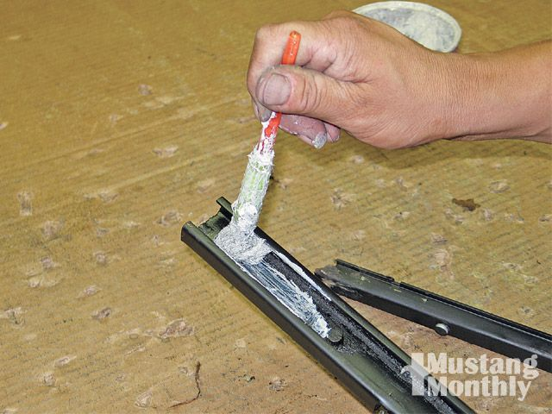
Once all the parts are cleaned, painted, and dry, begin reassembly by coating the tracks with white wheel-bearing grease. It's the right consistency and won't create a mess once the tracks are installed back onto the seat and into the car.

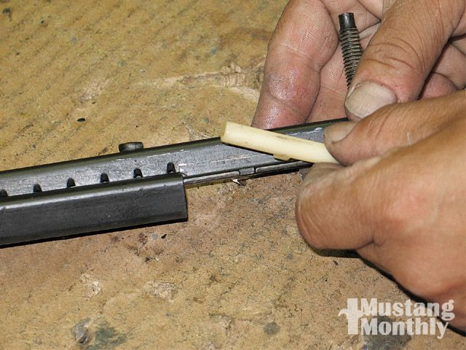
Slide the seat-mounting bars back into the tracks and, as you do so, reinstall the nylon tabs onto the seat bars. There are notches in the seat bars that accept the tabs on the nylon track bars. There are two at each end and four on each seat bar for a total of eight for each seat.

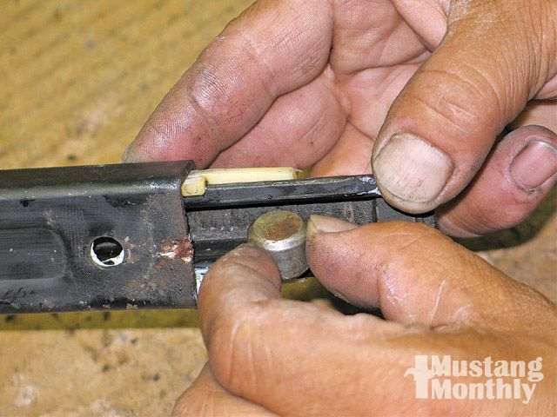
With the nylon bars in place and the seat bars installed far enough to hold the nylon pieces in place, place the bearings into the seat bar and, in turn, into the tracks as shown. There are four bearings in total, two for each track.

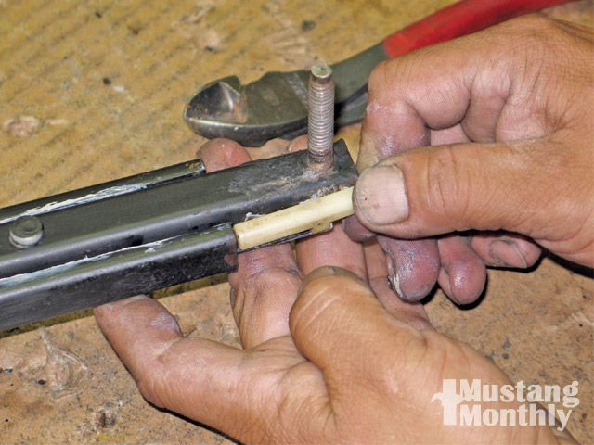
Continue installation of the final two nylon bars on each track once the seat bars are far enough in the track to hold the nylon bars in place.

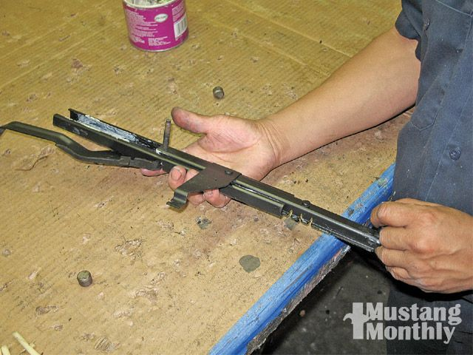
Complete assembly of the tracks by bending the tab back up and sliding the seat bar along the track to check for smooth operation

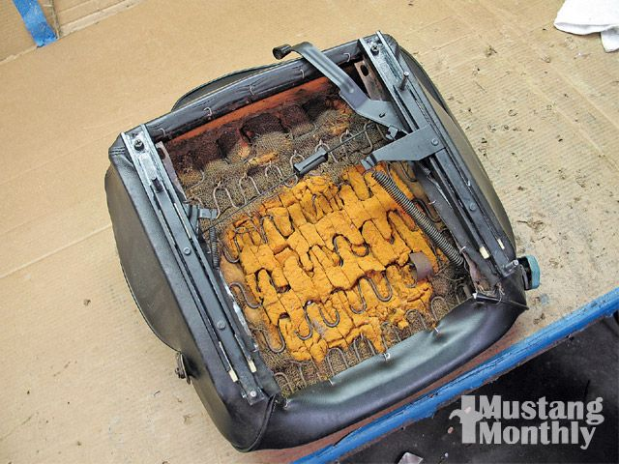
Reinstall the tracks onto the seats by screwing them into place and reinstalling the springs. That's it-you're set to go with freshly rebuilt seat tracks that will last another 40 years.

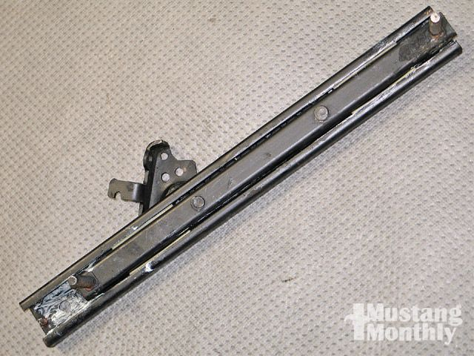
This is the repainted and reassembled secondary track that doesn't have the adjustment handle attached to it.

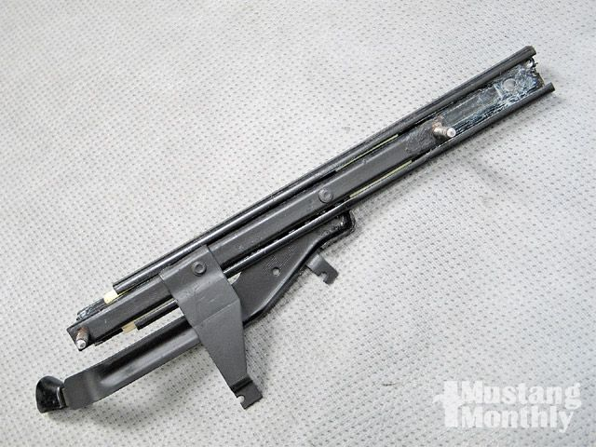
This is the primary track with the adjustment lever

