Fenstertechnik

1965-'66

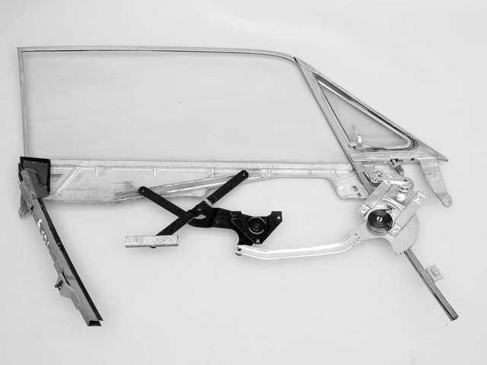
Maintaining Vintage Side Windows:

This is a typical '65-'66 Mustang window assembly as it appears insidethe door with the window rolled up. The reduction-gear regulator isoperated by the window crank. We crank a small gear, which drives alarge one, giving us mechanical advantage. As the window is cranked upand down, the regulator moves a scissor mechanism tied to the windowglass. From an operation standpoint, this is a good design. From amaintenance standpoint, it is a challenge. There are no rollers in thisdesign. The window glides up and down in felt and burlap-lined tracks.Adjustable stops in the glass and in the tracks determine window travellimits.

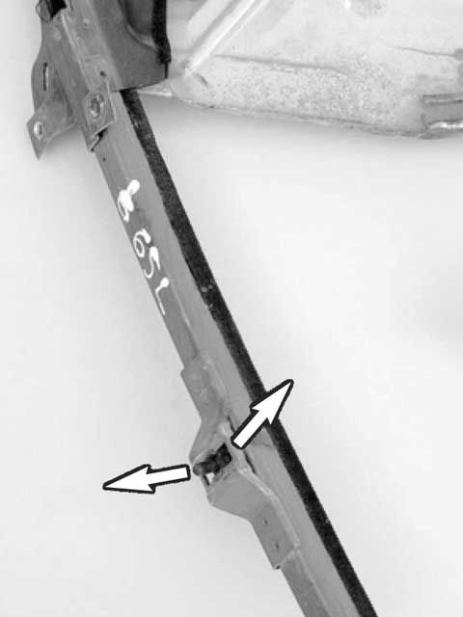
Maintaining Vintage Side Windows:

The burlap-lined window track supports the window glide. This guyadjusts in and out to control window-glass angle. Move it outward at thebottom, and the window glass moves inward at the top. Move it inward,and the glass moves outward up top. Make your adjustments, then run theglass up and down to check the adjustment. The window glass should liesnugly into the weatherstrip with the door closed.

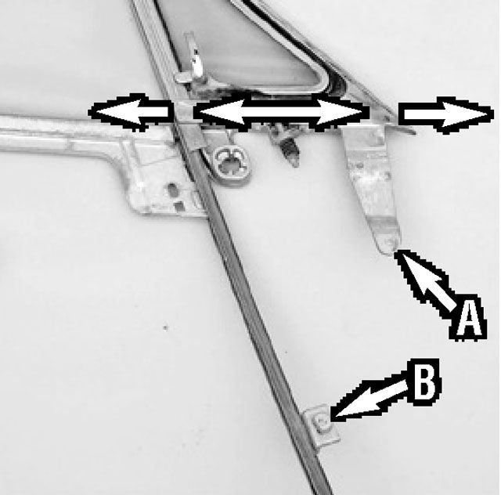
Maintaining Vintage Side Windows:

The forward track has two basic adjustments. The "A" adjustment controlsthe angle of the window at the wing assembly. Push it outward, and thewing assembly moves inward at the top. Move it inward, and the wingassembly moves out at the top. The "B" adjustment does the same thingfrom a greater distance. Move it outward with the screw adjustment, andthe window angles inward. The entire wing assembly also moves fore andaft in the door.

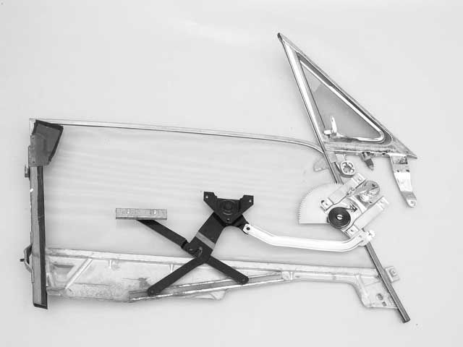
Maintaining Vintage:

This is the '65-'66 door-window mechanism with the window down. As youcan see, the scissor reverses. The key to smooth operation is properadjustment where the window glides up and down the two tracks fore andaft. Binding is what destroys window regulators and scissors.Side Windows

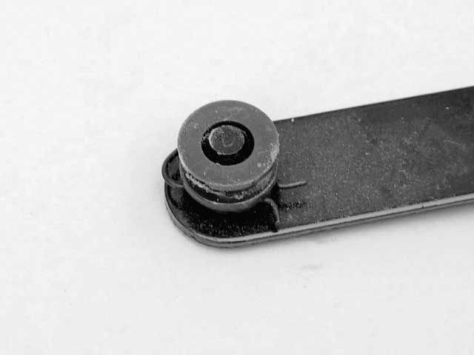
Maintaining Vintage Side Windows:
Rollers have a tough job. Keep them bathed in white grease and WD-40.Replace them immediately when they wear out or crack. For '65-'66models, there are only two of them in each door. Both are easy toservice with the door panel off.

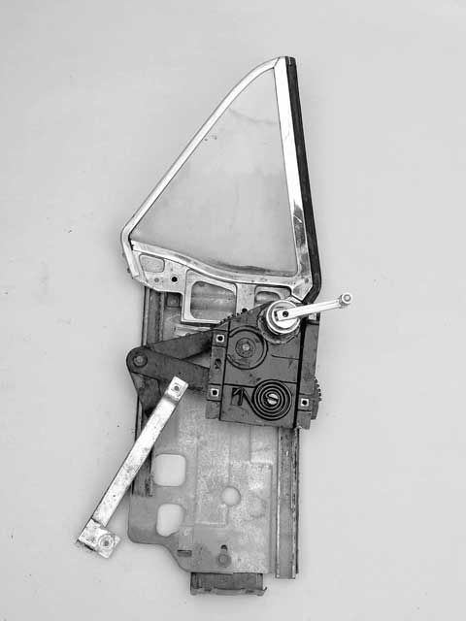
Maintaining Vint Rear quarter windows
In hardtops and convertibles they are simple. Except onconvertibles, they rarely wear out because they're seldom used. Thewindow glass glides up and down in a stamped-steel track assembly,which adjusts up and down with three adjustment points. It also adjustsin and out at the bottom. A bolt-on stop controls how low the glassgoes. Fixed stops at the top keep the glass from going too high.age Side Windows

1967-'68
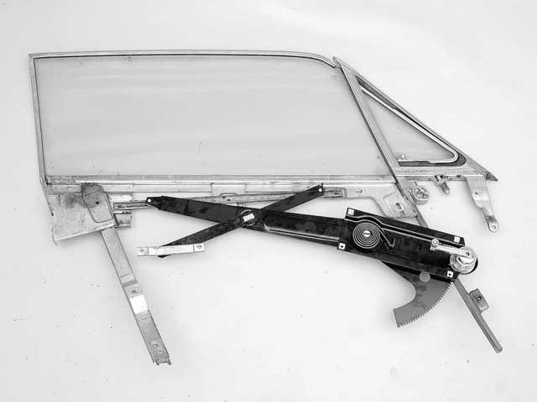
Maintaining Vintage Side Windows

The '67-'68 Mustang door windows have fewer moving parts, with thescissor becoming an integral part of the regulator.

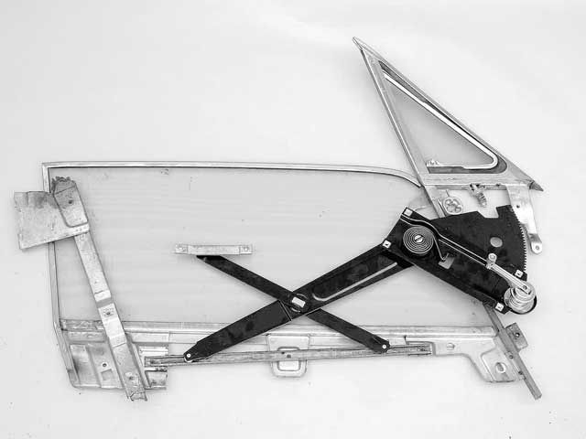
Maintaining Vintage Side Windows

Window down, the scissor reverses, just like it does in '65-'66 models

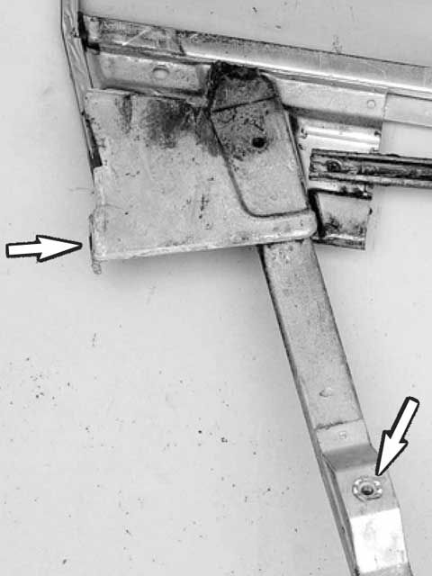
Maintaining Vintage Side Windows

Instead of a crude, burlap-lined window track, Ford went to rollers anda track for '67-'68. While this is a good design, it is less forgivingof adjustment error. The roller and track need lots of white grease forsmooth operation. This track adjusts in two places (see arrows) fortrack and window angle.

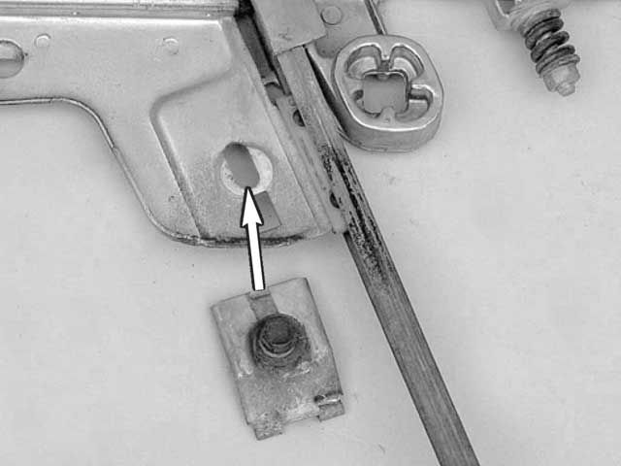
Maintaining Vintage Side Windows

At the wing window assembly, the window glass follows a path similar tothe '65-'66, with a stop (arrow) that controls window travel height. Thewing window assembly adjusts just like the '65-'66--in and out at topand bottom, plus fore and aft movement.

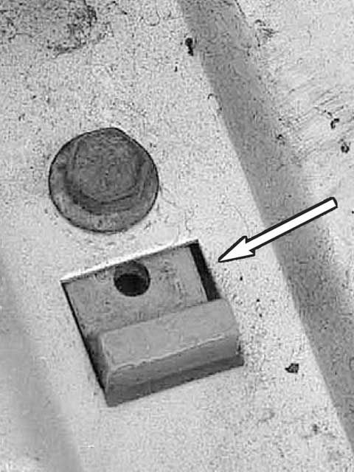
Maintaining Vintage Side Windows

Rollers follow the rear track for 1967-'68. The stop (arrow) limitstravel at the top

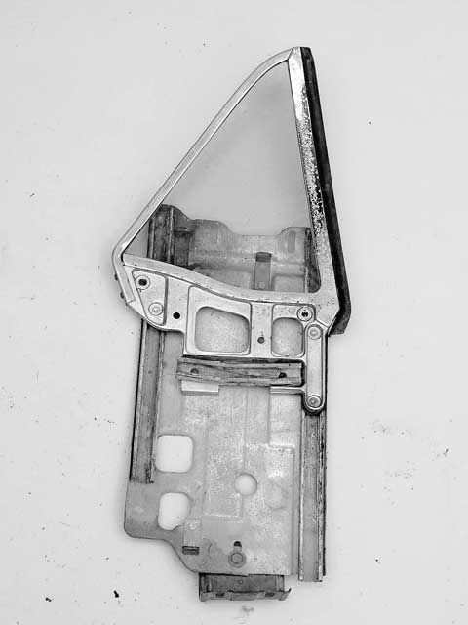
Maintaining Vintage Side Windows

Quarter-window assemblies for 1967-'68 are virtually the same as for1965-'66, except for roller size. For 1967-'68, rollers became largerfor smooth operation, thus they require plenty of white grease and WD-40for reliable service. Adjustments are identical to '65-'66 models. Thereis no bolt-on bottom stop.

1969-'70

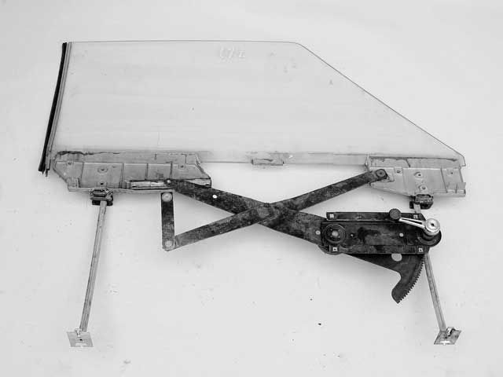
Maintaining Vintage Side Windows

For 1969-'70, Ford redesigned the Mustang windows, using dual tubularglides instead of window tracks to promote smoother operation, easiermaintenance, and simple adjustment. This is the '69 to early-'70 glue-inwindow, with the glass bonded to the brackets with an industrialadhesive. After years of use, the adhesive loses its grip. You can usenew adhesive or opt for the '70 bolt-in window.

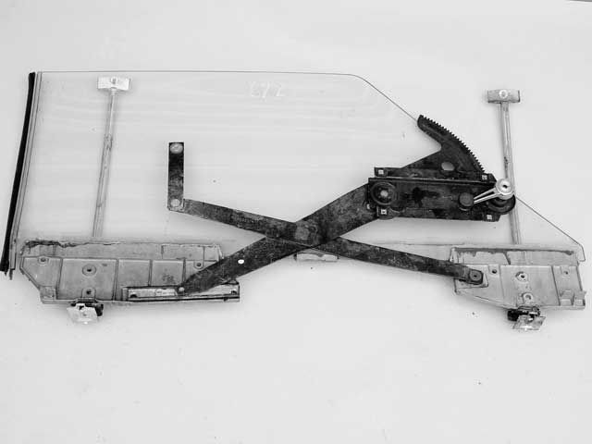
Maintaining Vintage

When rolling down the window, the arms scissor, just like in '65-'68models, with the window sliding down the tubular glides. Gone is the'65-'68 wing-window assembly.Side Windows

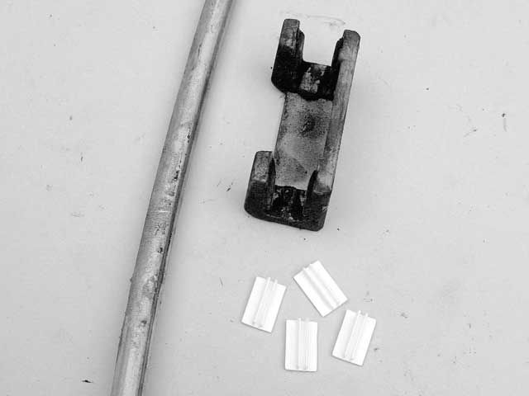
Maintaining Vintage Side
Windows

This is one of the two glides that rides the tubes. Plastic bushingsmake the glide smoother. Thesebushings wear out and bind, so keep plentyof white grease on them.

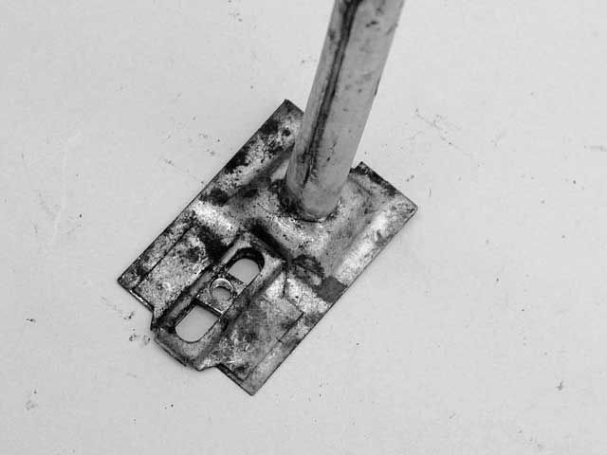
Maintaining Vintage Side Windows

Adjustment for 1969-'70 is performed in two places. The tubular glidesadjust in and out at the bottom and up and down at the top.

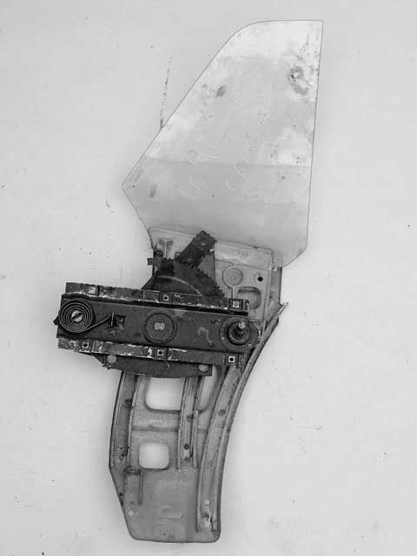
Maintaining Vintage Side Windows

Quarter-window assemblies changed completely for 1969-'70, but theirbasic operation didn't change much. A die-cast window bracket and glassride down the track, driven by a reduction-gear regulator. Adjustment issimilar to that of '65-'68 models: up and down, and in and out at thebottom. There are fewer moving parts for '69-'70 models

1971-'73

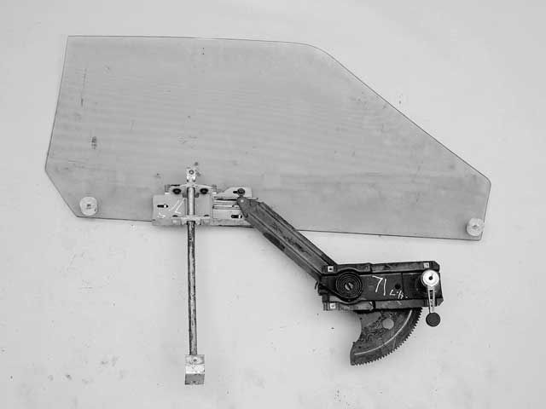
Maintaining Vintage Side Windows

Mustang windows became super simple for 1971-'73, with a single tubularglide and easy to replace bushings and regulator. Note the absence of anidler in this design.

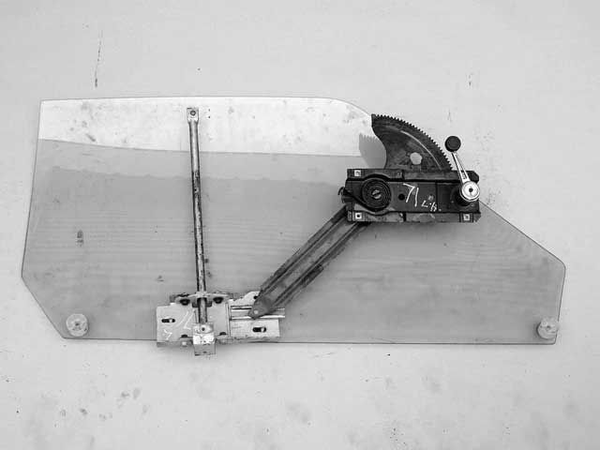
Maintaining Vintage Side Windows

This is the '71-'73 door window in the down position--no scissor oridler. Simple plastic stops halt window travel at the top.

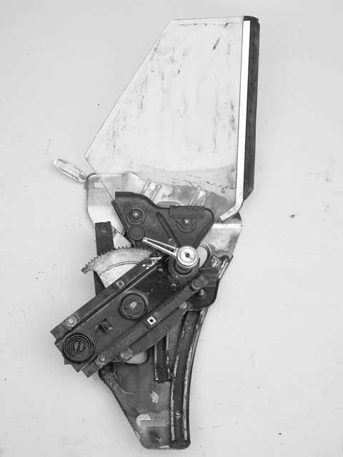
Maintaining Vintage Side Windows
Quarter-windows from 1971-'73, with three stops, are similar in functionto those from 1969-'70. The track rivets to the body, which makes itdifferent from '65-'70 models.

